­

INSTITUTIONAL TRAINING

Portfolio Website

ST_AZURE_1

PORTFOLIO WEBSITE

<https://reachajs.azurewebsites.net/>

Assignment Azure

BY: AMANJOT SINGH (20BCA1274)

Submission to: Ms Rydhm Beri

CODE OVERVIEW

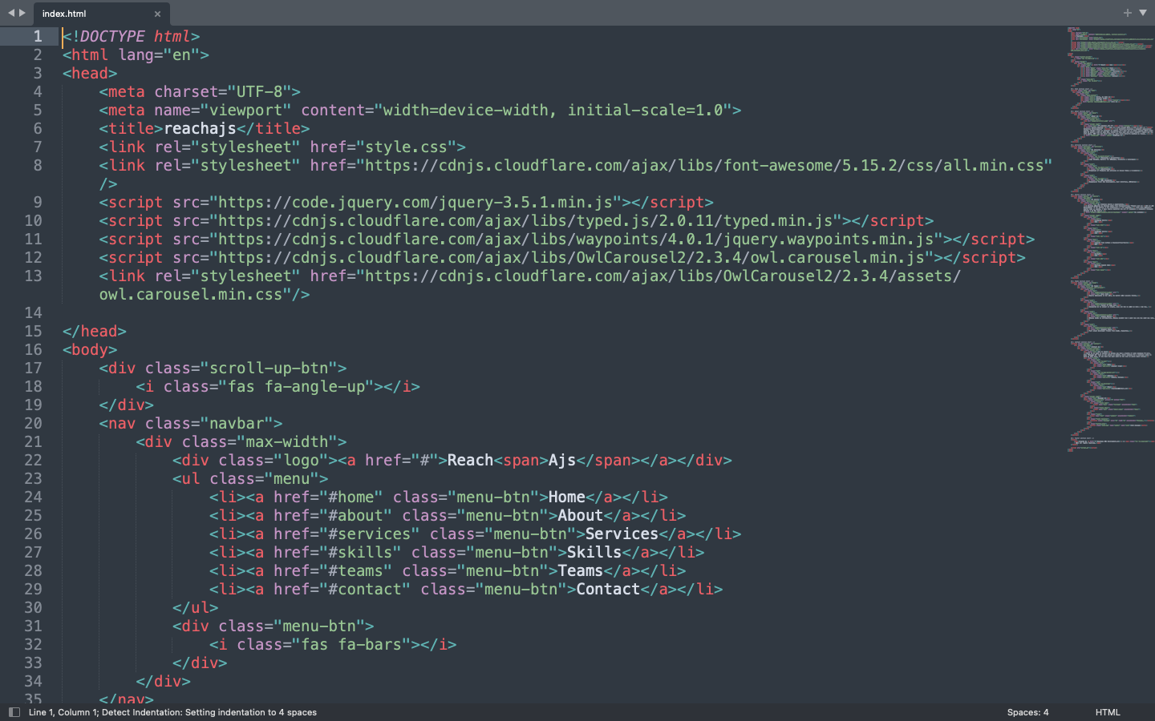

STEP 1: CREATED STATIC WEBPAGE USING HTML, CSS & Js

STEP 2: WENT TO MICROSOFT AZURE PORTAL

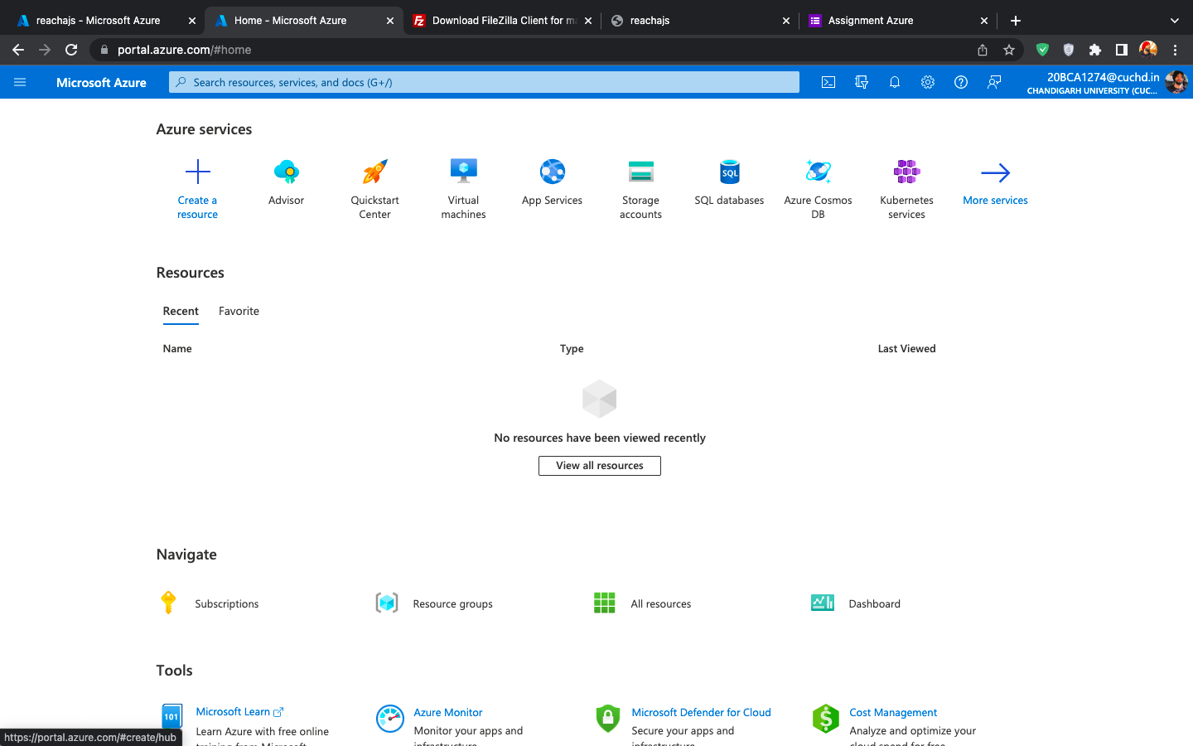

STEP 3: UNDER AZURE SERVICES CHOSE “CREATE A RESOURCE”

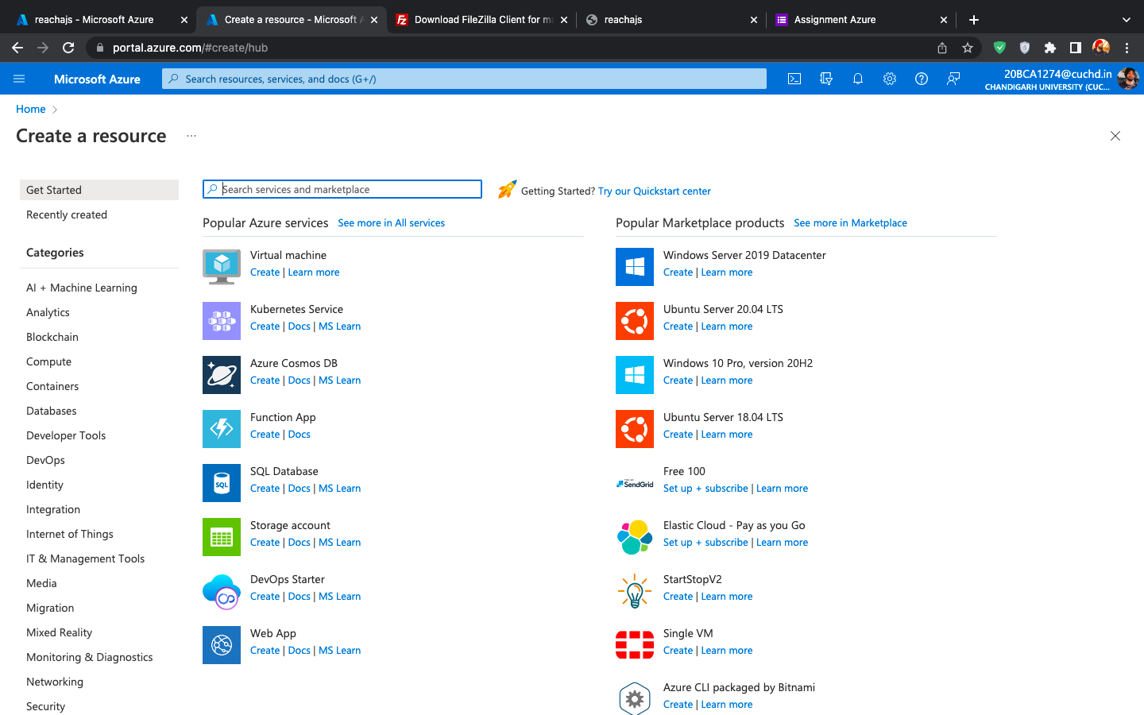

STEP 4: SELECTED WEB APP UNDER RESOURCES WITH FOLLOWING CONFIGURATIONS

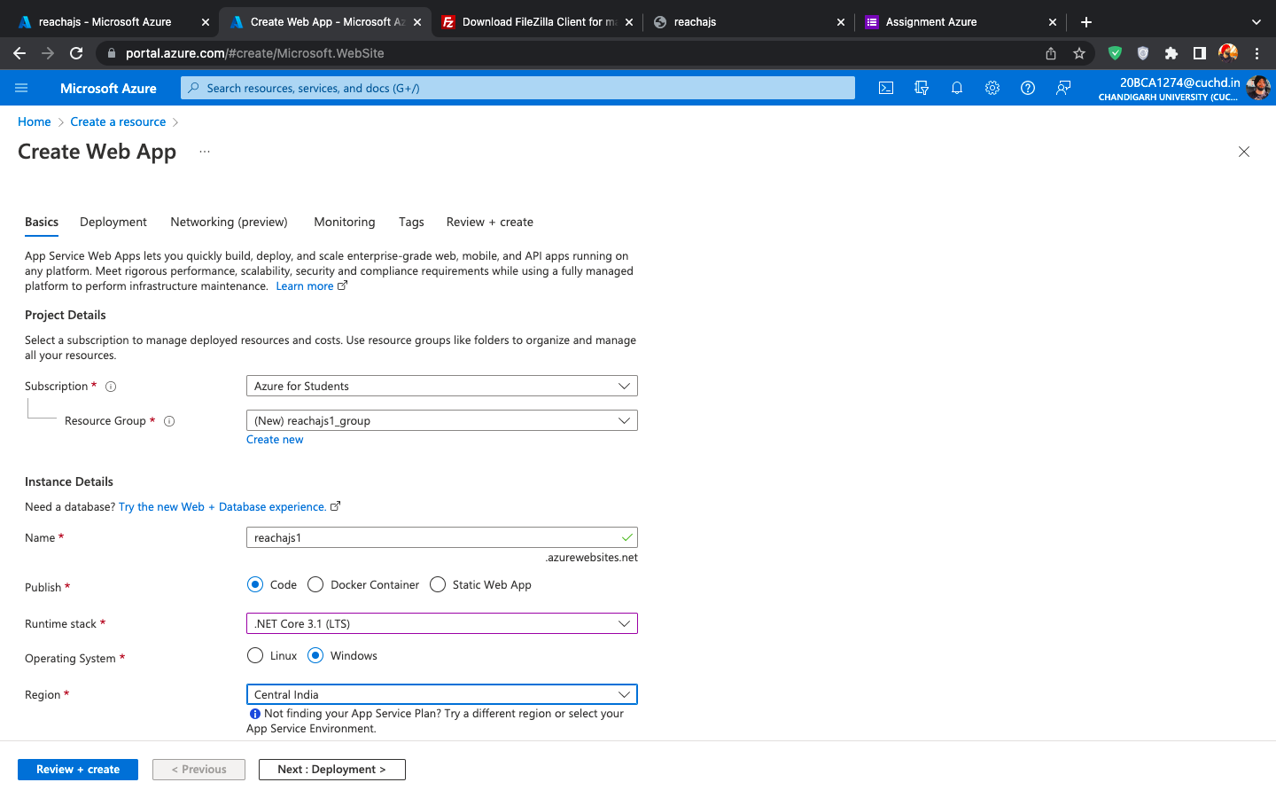

STEP 5: REVIEW+CREATE

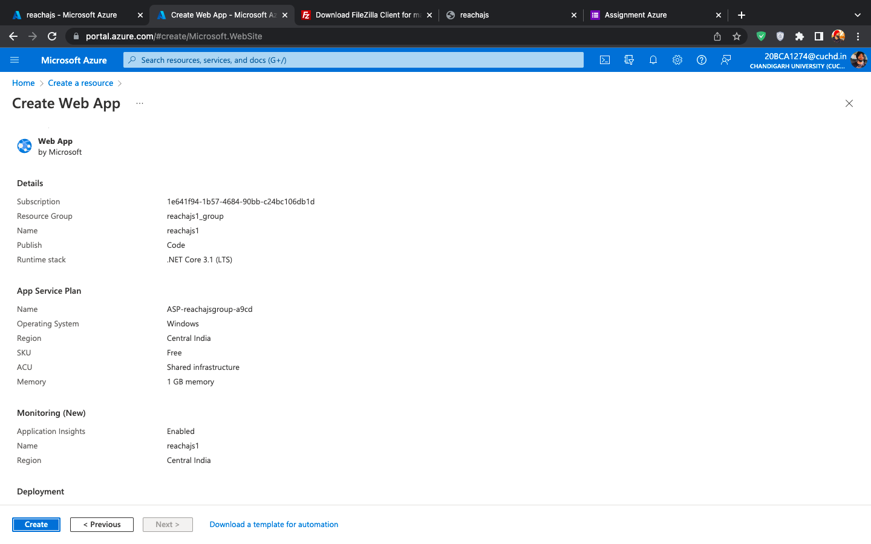

STEP 6: DEPLOYEMENT

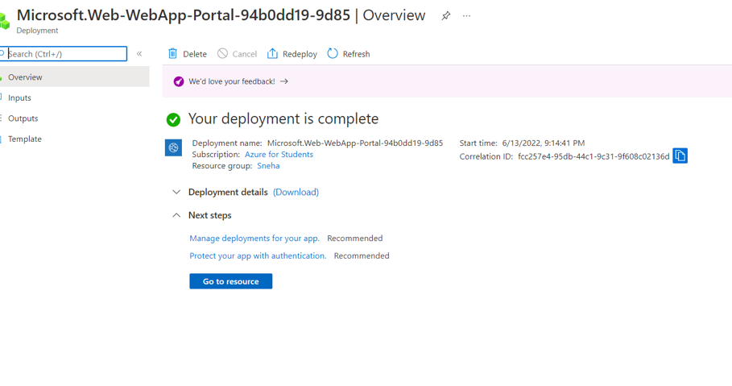

ONCE OUR DEPLOYEMENT IS COMPLETED CHOOSE MANAGE DEPLOYEMENTS

STEP 7: DOWLOADED FTP SOFTWARE TOOL FILE ZILLA TO CONNECT FTP SERVERS

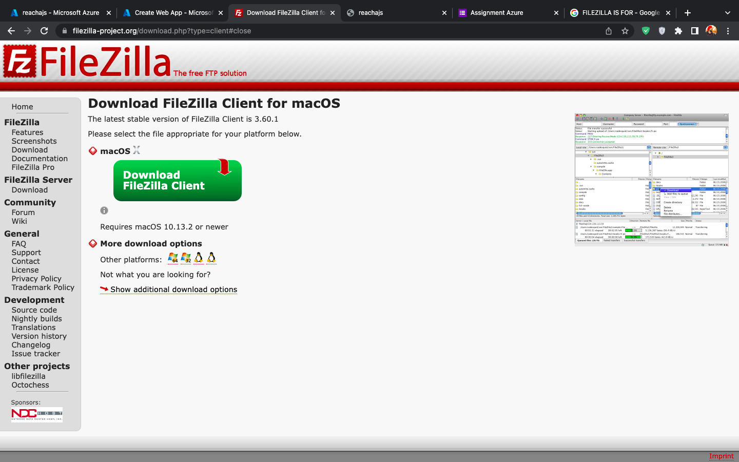

STEP 8: ACCESSED FTP CREDITIANLS UNDER DEPLOYMENT CENTER

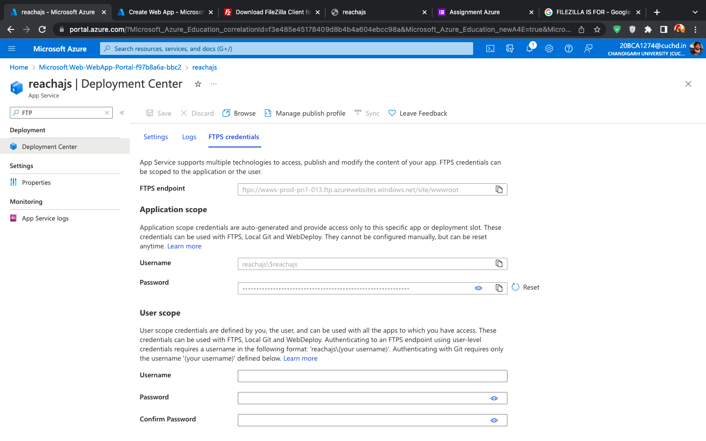

STEP 9: LOGIN USING FTP CREDITANIALS

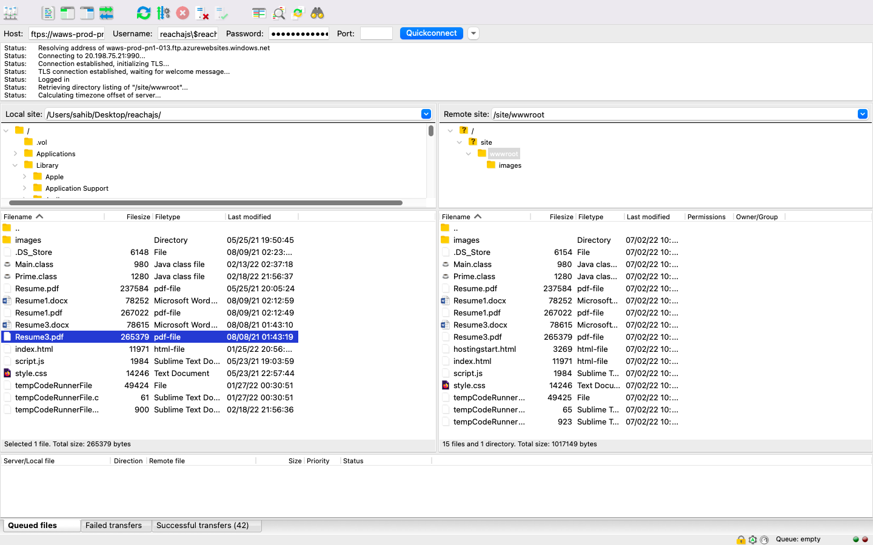

STEP 10: UPLOADED MY WEBPAGE FILES TO THE SERVER



STEP 11: USING URL AVAIALBLE ON AZURE HOME OVERVIEW PAGE ACCESSED MY WEBPAGE.

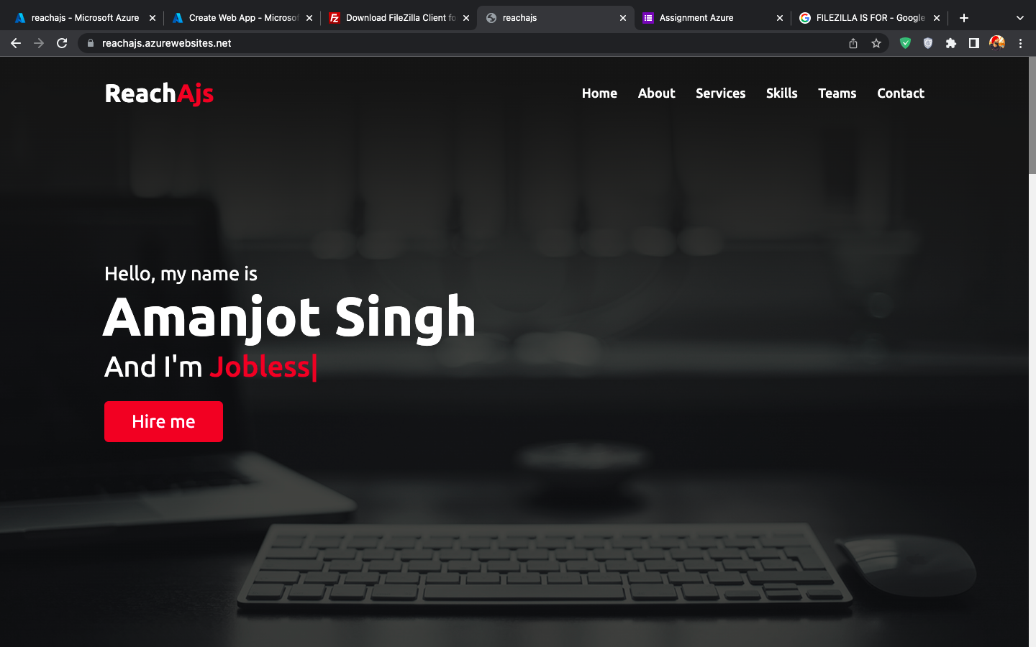

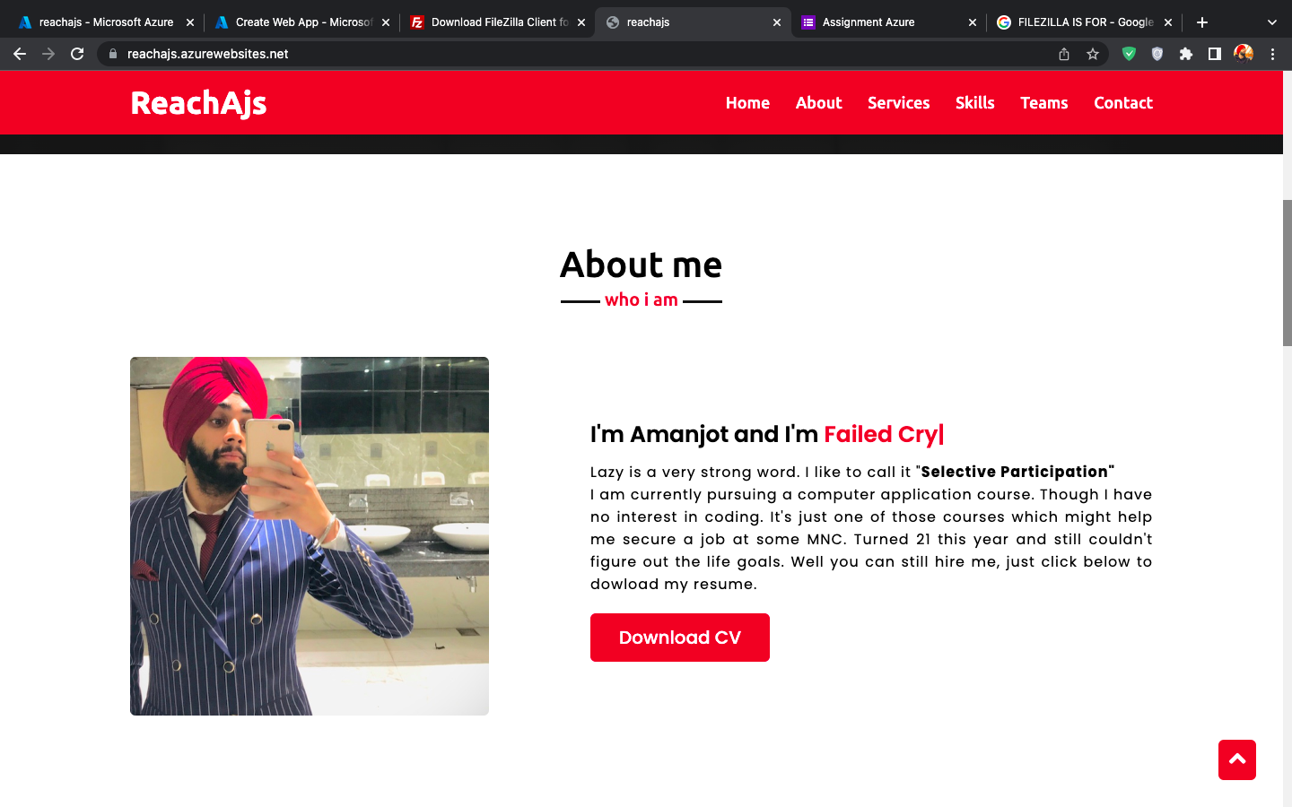

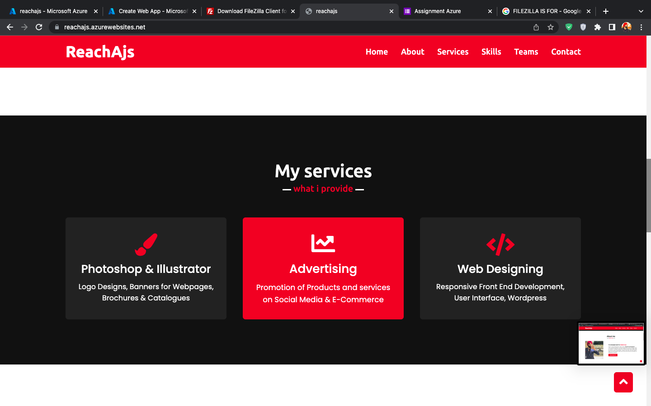

URL FOR THE WEBSITE: <https://reachajs.azurewebsites.net/>